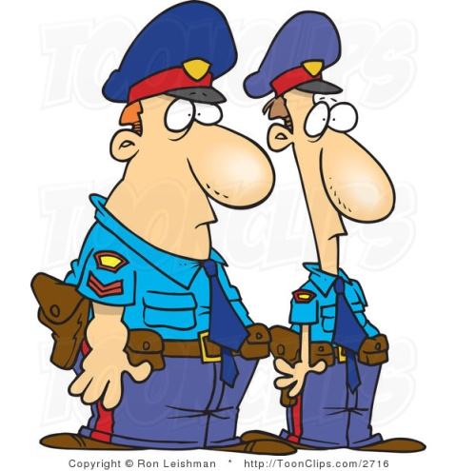
Policemen Card
Ask about the following:
- where and when they met
_______________________________________
- what the weather was like
_______________________________________
- what their friend was wearing _______________________________________
- where they were at 10 pm last night _______________________________________
- what they were doing at 10 pm last night _______________________________________
- what they ate or drank last night _______________________________________
- who they talked to last night _______________________________________
- any noises they heard _______________________________________
- ________________________ _______________________________________
- ________________________ _______________________________________

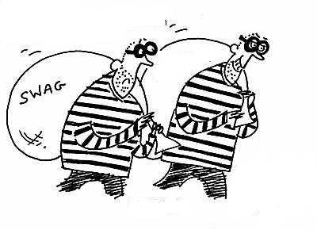
Suspects Card
Get together with your partner and think about:
- where and when you met __________________________________
- what the weather was like __________________________________
- what your friend was wearing _______________________________________
- where you were at 10 pm last night _______________________________________
- what you were doing at 10 pm last night _______________________________________
- what you ate or drank last night _______________________________________
- who you talked to last night _______________________________________
- any noises you heard _______________________________________
- ________________________ _______________________________________
- ________________________ _______________________________________

