Proud Peacock
By Ju Ziicloud

Which is the most beautiful of all the birds and animals? Yes, the peacock. But it was not as beautiful as it is today.
Long, long ago, deep in the forest, lived many birds and animals. One day, a fairy came and said to them, “If any of you don’t think you look nice enough, my magic can make you handsome or pretty.”
The animals and the birds all looked at each other. “I think I’m very good looking,” the monkey said, “but Colt’s face is too long.”
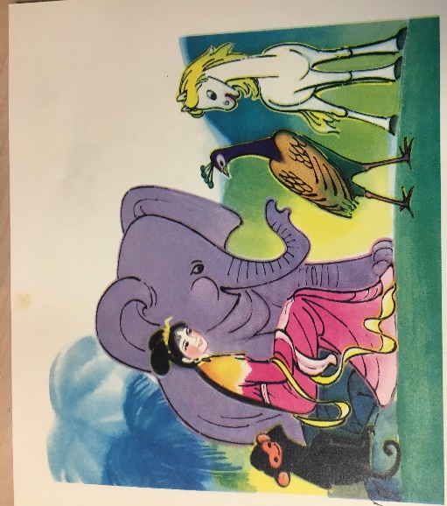
Colt was so cross he kicked Monkey several times. “I’m very handsome,” he said.” But I think Elephant’s trunk is too long. Could you take half of it off her her?”
Elephant was upset and lost her temper. “Just look how ugly Peacock is,” she said. “He’s the one who needs your help.”

Peacock was not offended at all. In fact, he was very pleased. “My tail’s much too short and tiny. It looks horrible. Please make it look better.”
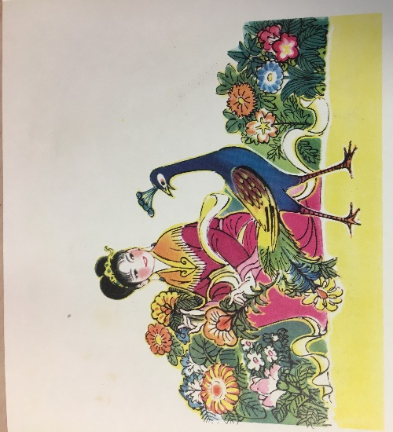
The fairy took the short feathers out of Peacock’s tail and put all kinds of beautiful flowers there instead. Then the fairy blew a magical breath. Peacock was now very handsome indeed.

When the fairy had gone, Peacock spread his tail. It looked very handsome in the sunlight.
All the other creatures were amazed. “It’s wonderful, Peacock!” they said. They all wished now that they had asked the fairy to help them.
Peacock started getting very proud. Whenever he met another bird with beautiful feathers, he spread his tail to show that his feathers were even finer.

One day, Peacock saw another bird in the lake. It had beautiful feathers too. He spread his tail to show the other bird that he was even more handsome.
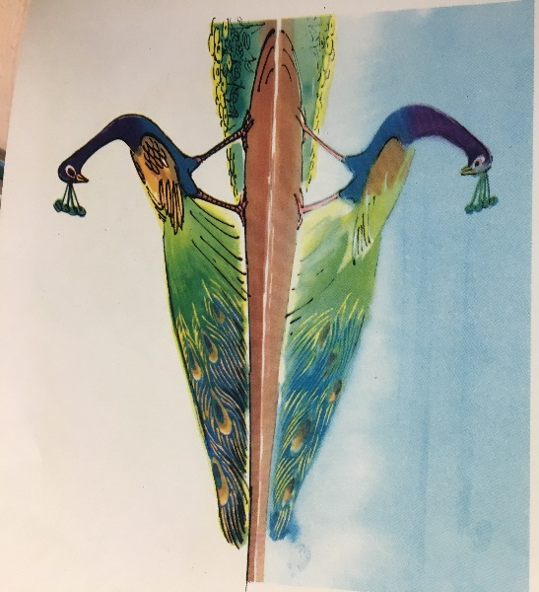
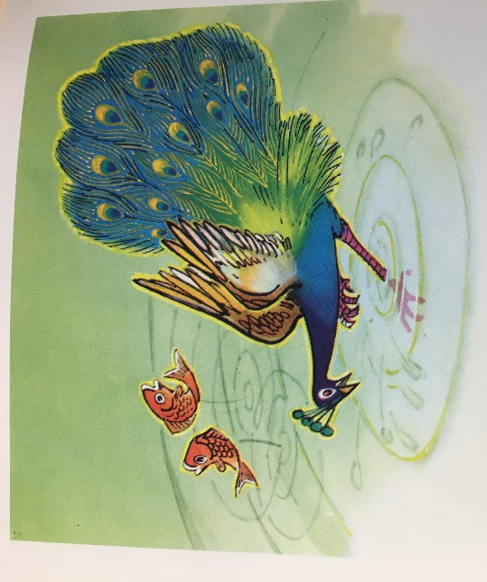
The strange thing was that the bird in the water did exactly the same. It spread out a very fine tail too.
Peacock was so cross he jumped on the bird in the water to attack it with his beak. He fell into the water. Peacock could not swim and kept swallowing water. He was drowning.
Luckily for him, there was a tree right at the edge of the lake with roots growing in the water. He held on to them and just managed to pull himself ashore.
When he looked back at the water he was very pleased to see that the other bird looked wet, bedraggled, and ugly.
A magpie in the tree by the lake started laughing. “Ugly old magpie,” snapped Peacock angrily, “what do you think you’re laughing at?”
Magpie managed to stop laughing for long enough to say, “I’m laughing at you. The bird you saw in the water just now was your own reflection.”
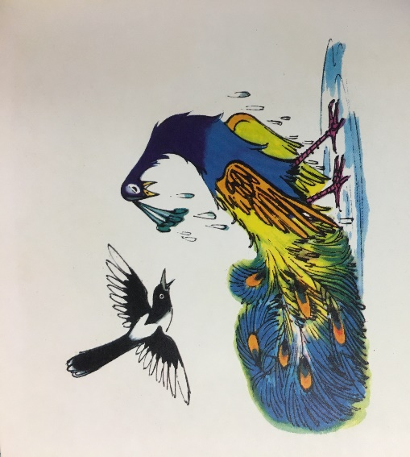
Peacock looked at his own wet, bedraggled feathers. He looked hideous. He felt very silly indeed.

