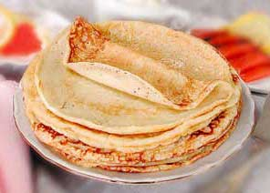
Pancakes

You will need:
- flour
- milk
- salt
- sugar
- sunflower oil

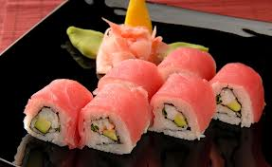
Fried eggs with tomatoes
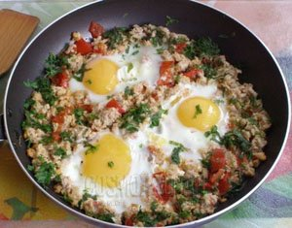

You will need:
- eggs
- tomatoes
- meat
- salt
- sunflower oil

Fruit salad
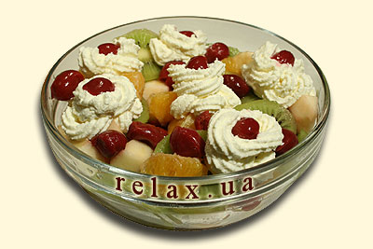

You will need:
- kiwi
- tangerine
- cherry
- apple
- whipped cream

Japanese rolls

You will need:
- rice
- salmon
- cucumber
- salt
- pickled ginger

Pizza
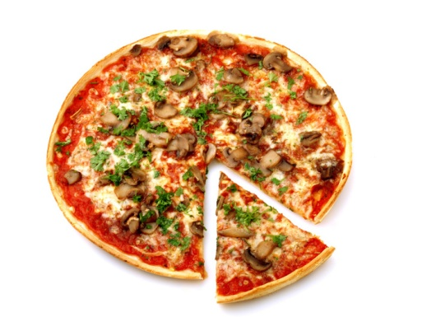

You will need:
- flour
- tomatoes
- parsley
- mushrooms
- olives

Fried potatoes with chicken

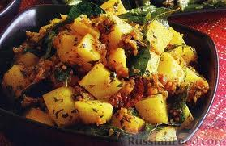

You will need:
- potatoes
- chicken
- sunflower oil
- salt
- parsley

Pasta
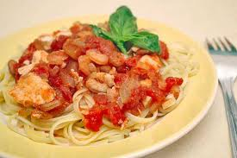

You will need:
- macaroni
- meat
- shrimps
- onion
- salt

Meat dumplings

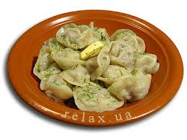

You will need:
- flour
- minced meat
- salt
- butter
- parsley

