Superstitions
Work with your group to guess the correct answers. You can wager your points for each question. If your group gets the question correct, you earn those points! But if you are incorrect, you lose those points! Wager wisely!
1) If you find a four leaf clover,
- it is bad luck.
- it is good luck.
- you will get married soon.
2) If you throw rice on a new bride and groom,
- it is good luck for seven years.
- they will have many children.
- they will be married for ten years.
3) If you hang garlic in your house,
- bad spirits won’t enter.
- you will have good dreams.
- you will never get married.
4) If your ears are burning,
- someone is talking about you.
- someone will say bad things about you.
- you will travel soon.
5) If you pull out one grey hair,
- you will grow old faster.
- two more grey hairs will grow back.
- ten more grey hairs will grow back.
6) You will have good luck if ______________ on your wedding day.
- you meet a black cat
- you see a pig cross the road
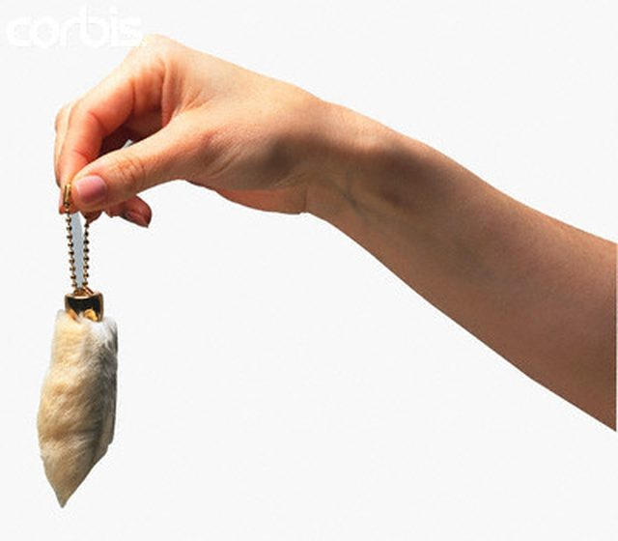
- it rains
7) If you drop scissors,
- your lover will be unfaithful.
- it is bad luck.
- you will hear bad news soon.
8) If you keep a rabbit’s foot in your pocket
- it will keep the bad spirits away.
- it is good luck.
- you will become rich and famous.

